

Syeda Reeha Quasar

14114802719

Abstract

Develop a complete limited entry decision table for the following decision situation:

An airline offers only flights in Germany and Europe. Under special conditions a discount is offered — a discount with respect to the normal airfare.

Experiment - 4

Software Testing and Quality Assurance

# **EXPERIMENT – 4**

## **Aim:**

Develop a complete limited-entry decision table for the following decision situation:

An airline offers only flights in Germany and Europe. Under special conditions a discount is offered — a discount with respect to the normal airfare.

**Rules:**

* + Passengers older than 18 with destinations in Germany are offered a discount at 20%, if the departure is not on a Monday or Friday- If the passengers stay at least 6 days at the destination, an additional discount of 10% is offered.
  + For destinations outside Of Germany passengers are offered a discount Of 25%, if the departure is not on a Monday or Friday.
  + Passengers older than 2 but younger than 18 years are offered a discount of 40% for all destinations.
  + Children under 2 travel for free.

For each rule, design the test case

## **Theory:**

A decision table is a brief visual representation for specifying which actions to perform depending on given conditions. The information represented in decision tables can also be represented as decision trees or in a programming language using if-then-else and switch-case statements.

A decision table is a good way to settle with different combination inputs with their corresponding outputs and is also called a cause-effect table. The reason to call cause-effect table is a related logical diagramming technique called cause-effect graphing that is basically used to obtain the decision table.

**Importance of Decision Table:**

* Decision tables are very much helpful in test design techniques.
* It helps testers to search the effects of combinations of different inputs and other software states that must correctly implement business rules.
* It provides a regular way of starting complex business rules, that is helpful for developers as well as for testers.
* It assists in the development process with the developer to do a better job. Testing with all combinations might be impractical.
* A decision table is basically an outstanding technique used in both testing and requirements management.
* It is a structured exercise to prepare requirements when dealing with complex business rules.
* It is also used in model complicated logic.

**Advantages of Decision Table:**

* Any complex business flow can be easily converted into test scenarios & test cases using this technique.
* Decision tables work iteratively which means the table created at the first iteration is used as input tables for the next tables. The iteration is done only if the initial table is not satisfactory.
* Simple to understand and everyone can use this method to design the test scenarios & test cases.
* It provides complete coverage of test cases which helps to reduce the rework on writing test scenarios & test cases.
* These tables guarantee that we consider every possible combination of condition values. This is known as its completeness property.

## **Solution:**

**Airline Passenger Discount Policy**

An airline offers only flights to India and Asia. Under special conditions, a discount is offered on the normal airfare:

* Passengers older than 18 with destinations in India are offered a discount of 20%, as long as the departure is not on a Monday or Friday.
* For destinations outside of India, passengers are offered a discount of 25%, if the departure is not on a Monday or Friday.
* Passengers who stay at least 6 days at their destination receive an additional discount of 10%.
* Passengers older than 2 but younger than 18 years are offered a discount of 40% for all destinations.
* Children 2 and under travel for free.

**Extracting Rules**

**Conditions:**

* Destination (India, Asia)
* Passenger Age (<= 2, > 2 && < 18, > 18
* Depart on Monday or Friday (Yes, No)
* Stay 6 days or more (Yes, No)

**Actions:**

* Travel Free
* 0% discount
* 10% discount
* 20% discount
* 40% discount

**Number of rules:** 2 values * 3 values * 2 values * 2 values = 24 rules

**Scenarios**

[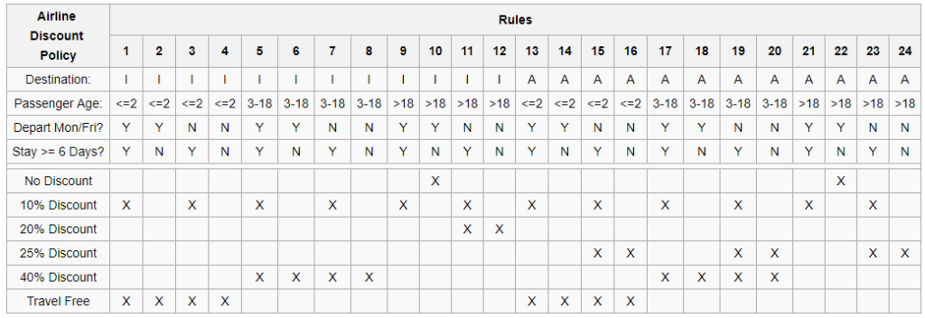](https://resource.flexrule.com/wp-content/uploads/2019/07/scenarios.png)

**Reduced Table**

[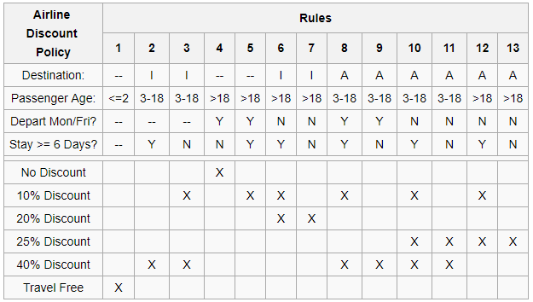](https://resource.flexrule.com/wp-content/uploads/2019/07/reduced-table.png)

## **Decision Table:**

|  |  |  |  |  |  |
| --- | --- | --- | --- | --- | --- |
|  | Destination | Age | IsWeekDay | MoreThan6 | Discount |
| Rule 1 |  | Group1 |  |  | 100 |
| Rule 2 | India | Group2 |  | Y | 40 |
| Rule 3 | India | Group2 |  | N | 50 |
| Rule 4 |  | Group3 | Y | N | 0 |
| Rule 5 |  | Group3 | Y | Y | 10 |
| Rule 6 | India | Group3 | N | Y | 30 |
| Rule 7 | India | Group3 | N | N | 20 |
| Rule 8 | Asia | Group2 | Y | Y | 50 |
| Rule 9 | Asia | Group2 | Y | N | 40 |
| Rule 10 | Asia | Group2 | N | Y | 75 |
| Rule 11 | Asia | Group2 | N | N | 65 |
| Rule 12 | Asia | Group3 | N | Y | 35 |
| Rule 13 | Asia | Group3 | N | N | 25 |

## **Result:**

For each rule test-case was designed and verified.

# **Viva Questions**

**Q1. Why we use decision tables?**

The techniques of equivalence partitioning and boundary value analysis are often applied to specific situations or inputs. However, if different combinations of inputs result in different actions being taken, this can be more difficult to show using equivalence partitioning and boundary value analysis, which tend to be more focused on the user interface. The other two specification-based tech-niques, decision tables and state transition testing are more focused on business logic or business rules. A decision table is a good way to deal with combinations of things (e.g. inputs). This technique is sometimes also referred to as a 'cause-effect' table. The reason for this is that there is an associated logic diagramming technique called 'cause-effect graphing' which was sometimes used to help derive the decision table.

**Q2 What are the disadvantages of Decision Table testing?**

The main disadvantage is that when the number of inputs increases the table will become more complex.

**Q3. Why Decision Table Testing is Important?**

Decision Table Testing is Important because it helps to test different combinations of conditions and provides better test coverage for complex business logic. When testing the behavior of a large set of inputs where system behavior differs with each set of inputs, decision table testing provides good coverage and the representation is simple so it is easy to interpret and use.

In Software Engineering, boundary value and equivalent partition are other similar techniques used to ensure better coverage. They are used if the system shows the same behavior for a large set of inputs. However, in a system where for each set of input values the system behavior is different, boundary value and equivalent partitioning technique are not effective in ensuring good test coverage.In this case, decision table testing is a good option.

This technique can make sure of good coverage, and the representation is simple so that it is easy to interpret and use.

This table can be used as the reference for the requirement and for functionality development since it is easy to understand and cover all the combinations.

**Q4. What are the advantages of Decision Table Testing?**

1. When the system behavior is different for different inputs and not the same for a range of inputs, both equivalent partitioning, and boundary value analysis won’t help, but a decision table can be used.
2. The representation is simple so that it can be easily interpreted and is used for development and business as well.
3. This table will help to make effective combinations and can ensure better coverage for testing
4. Any complex business conditions can be easily turned into decision tables
5. In a case we are going for 100% coverage typically when the input combinations are low, this technique can ensure the coverage.

**Q5: Why is Decision Table also called a Cause-Effect table?**

Decision table testing is a software testing technique used to test system behavior for different input combinations. This is a systematic approach where the different input combinations and their corresponding system behavior (Output) are captured in a tabular form. That is why it is also called as a **Cause-Effect** table where Cause and effects are captured for better test coverage.